Network Security Essentials

Aim:
To understand network security fundamentals and analyze firewall, VPN, and IDS
logs to detect suspicious activities such as port scanning, brute-force attacks, and network breaches.

The networks are the backbone of every modern organization. Servers, workstations, applications, and security devices don’t exist in isolation; they are interconnected, forming a single ecosystem**. T**his room will introduce us to the fundamental concepts of network security from a defensive perspective. While our focus will be on the logs and data sources we encounter daily, we’ll start by building a strong understanding of how networks are structured, why they are essential to protect, and why monitoring the perimeter is critical for early detection of attacks.

Link to the room: https://tryhackme.com/room/networksecurityessentials

TASK 2: Lab Connection

TASK 3: A Network — Overview

To understand network security, it is essential to comprehend what a network is, the components or assets that form it, and how these components work together.

Use the link and read the rest of the information. no answer needed

TASK 4: Network Visibility Continue to read to understand No answer needed
TASK 5: Network Perimeter Continue to read to understand No answer needed

TASK 6: Network Perimeters: Monitoring and Protecting

Monitoring the perimeter involves utilizing firewalls, intrusion detection/prevention systems (IDS/IPS), and access control to examine and limit exposure, while enforcing security rules. We will have to do the reading to effective answer the questions.

Q1: Examine the firewall logs. Which IP address is performing the port scan?

When we open the file, we see a series of TCP blocks attempted from an IP of 203.0.113.10. This indicates that an attacker is testing our network to determine which ports are open or closed, while the firewall is performing its job and blocking them.

Ans: 203.0.113.10

Q2: In the WAF Logs, which single source IP is responsible for all the blocked web attacks?

Ans: 198.51.100.12

Q3: In the VPN logs, how many brute-force attempts failed?

From the logs, we can see that an attacker is attempting to guess a user’s password to gain remote access to the network, which generates a significant amount of noise in the authentication logs.
which will create a lot of failed_auth attempts. Since it is a log file, a .txt, I searched only for words that say FAILED_AUTH and then counted how many there are.

Ans: 90

Q4: Which suspicious IP address was found attempting the brute-force attack against the VPN gateway?

Still from the same log file, we can see that all the failed_auth came from a certain IP with no user; every instance goes to an internal IP with different usernames at different instances.

Ans: 45.137.22.13

TASK 7: Perimeter Logs: Investigating the Breach

Q1: Examine the firewall logs. What external IP performed the most reconnaissance?

This is simply a matter of finding the IP address with the most scans. I used the manual method with the command line. I then navigated to the directory where the logs were located. In this question, we will be looking for the IP with the most block requests. We first analyze the firewall logs for any block requests using the command cat firewall.log | grep “BLOCK”
| head to read just the top of the log file, and the blocked requests indicate that an external IP has been found probing against internal IPs using various ports (22,23,21,445,4444). To then understand which IP is responsible for the maximum BLOCK requests. We ran the command cat firewall.log | grep “BLOCK” | cut -d’ ‘ -f5 | cut -d: -f1 | sort -nr | uniq -c

Press enter or click to view image in full size
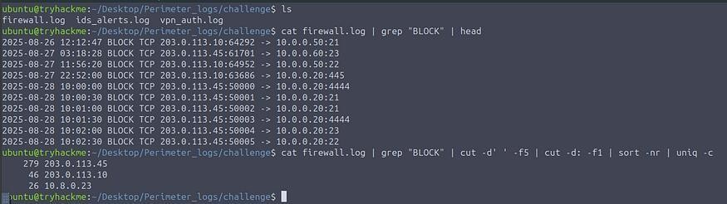

Ans: 203.0.113.45

Q2: In the firewall log, Which internal host was targeted by scans?

And: 10.0.0.20

Q3: Which username was targeted in VPN logs?

We first examine the number of failed attempts, using the following command cat vpn_auth.log | grep FAIL | cut -d’ ‘ -f3 | sort -nr | uniq -c, We can clearly see that the suspicious IP from the above question has multiple failed VPN login attempts. Let’s now use the following command cat vpn_auth.log | grep 203.0.113.45 to narrow down on the suspicious IP, we then see multiple login attempt was made against a certain user svc_backup which resulted into failed and eventually down the line was successful.

Press enter or click to view image in full size
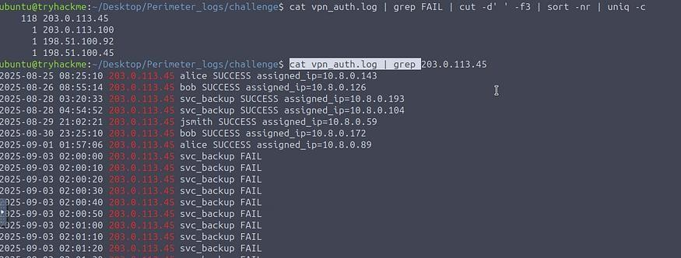

Ans: svc_backup

Q4: What internal IP was assigned after successful VPN login?

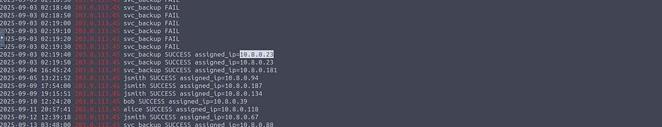
Scrolling down from the same output above, we can see a successful login and an assigned IP. Press enter or click to view image in full size

Ans 10.8.0.23

Q5: Which port was used for lateral SMB attempts?

By now, we have confirmed that the attacker has successfully gained initial access and obtained an internal IP address. Let’s filter through the firewall logs and see if we can find the footprints of any lateral movement from the compromised host IP of 203.0.113.45 using the command cat firewall.log | grep “203.0.113.45” | grep “ALLOW” | head
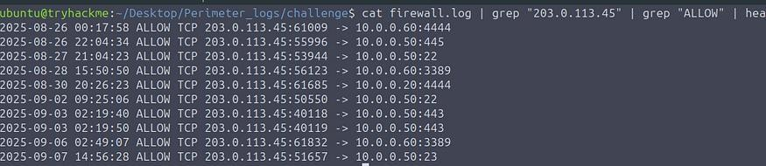

From the output, we can observe that the compromised IP is probing internal machines 10.0.0.20, 10.0.0.51, 10.0.0.60 on various ports on three main ports SMB/RDP/SSH (445/3389/22)

Ans: 445

Q6: In the IDS logs, which host beaconed to the C2?

Examining the IDS alerts reveals a specific alert related to C2 Beaconing, indicating potential C2 communication. We use the command cat ids_alerts.log | grep C2 | head

Press enter or click to view image in full size
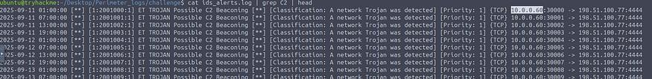

The output clearly confirms our suspicion about one of the internally compromised hosts.

Ans: 10.0.0.60

Q7: During the investigation, which IP was observed to be associated with C2?

We will then filter against the compromised IP responsible for C2 beaconing, using the command cat ids_alerts.log | grep -n “10.0.0.60” | cut -d’ ‘ -f6,7,8,9,10,19,22,23 | head -n 15

Press enter or click to view image in full size
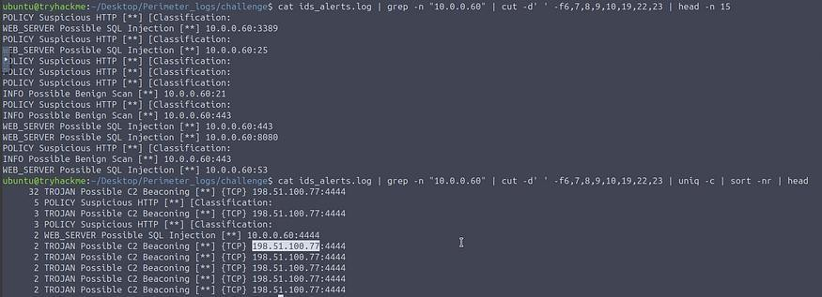

The output further confirms that the infected host is engaging in suspicious activities. We can use the following command: cat ids_alerts.log | grep -n “10.0.0.60” | cut -d’ ‘ - f6,7,8,9,10,19,22,23 | uniq -c | sort -nr | head to show the stats of the alerts triggered against the infected host.

Ans: 198.51.100.77

Q8: Which host showed the exfiltration attempts?
Now that we have identified the C2 communication and examined other alerts against suspicious IPs, let’s investigate if there are any indicators of data being exfiltrated from our network. We will apply a filter on the compromised hosts and examine the traffic originating from those to an external destination IP. We use the command cat firewall.log | grep “198.51.100.77” | cut -d’ ‘ -f5,6,7 | uniq | sort.

Press enter or click to view image in full size
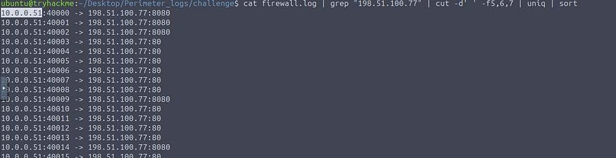

The output clearly indicates that the compromised host IP is sending a substantial amount of traffic to an external IP address.

Ans: 10.0.0.51

TASK 8: Conclusion

If you’ve learned something, please like and follow for more content.

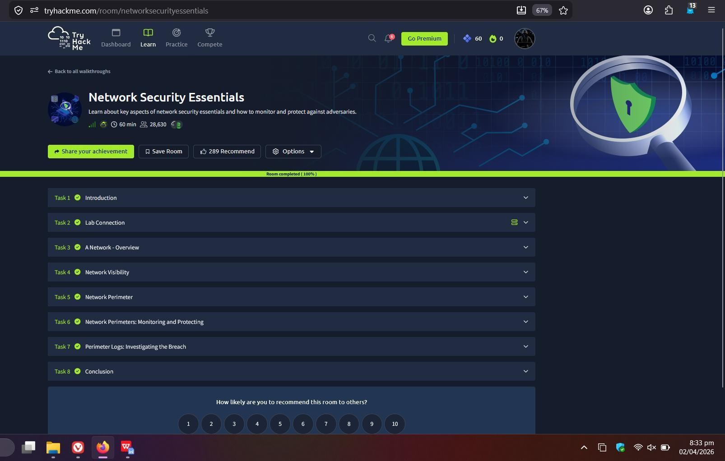

Result:
Successfully identified malicious activities including port scans, brute-force attempts, compromised hosts, C2 communication, and data exfiltration by analyzing different network logs and determining the responsible IP addresses.

